Before beginning a class, make sure you have completed the steps below:
- Disable any pop-up blockers that are enabled on your web browser.
- Please add https://cji.blackboard.com/ultra/stream to your allowable pop-ups list.
- Please disable any extensions that prevent videos from playing automatically.

Log into Genius with your username and password. Under the Active Courses window, you should see the online class listed. Click on the name of the class.
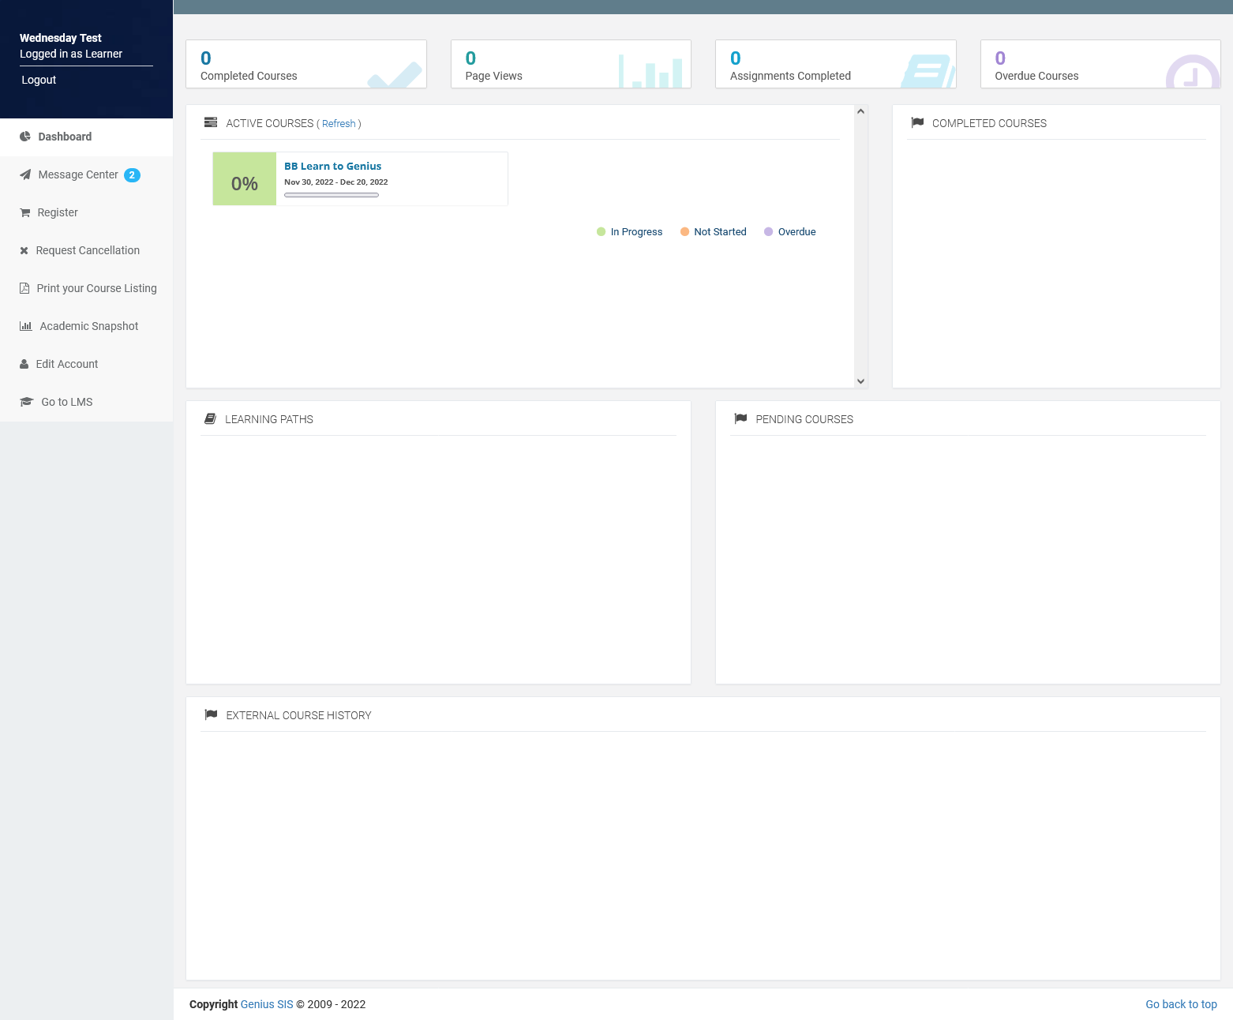
When you click on the class, a second tab will open the class in Blackboard Learn. Here you will see the course content. Click on the first block that says Begin Here:
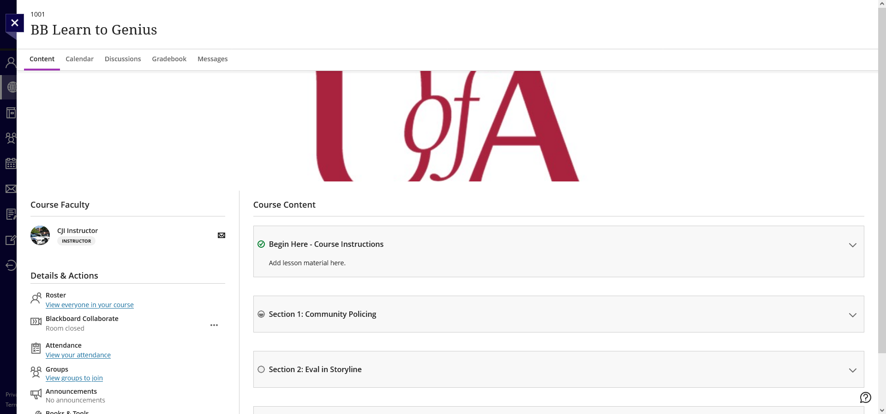
The block will expand to show the class content – click on the content to see it.
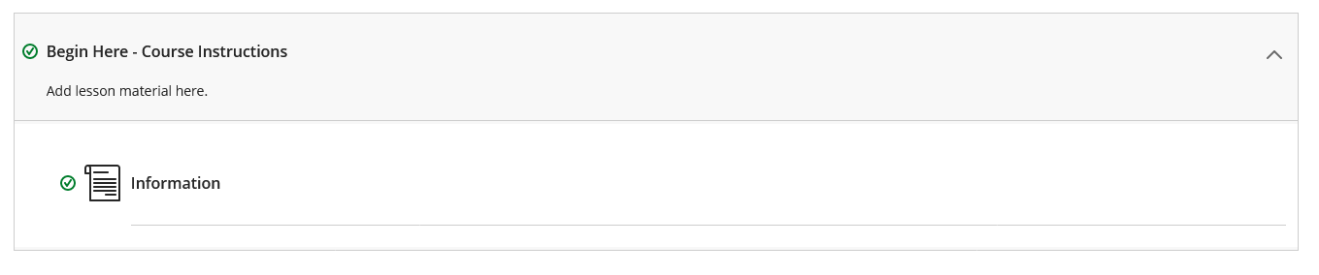
To close the content when you are finished, click on the X on the upper left corner by the class name.
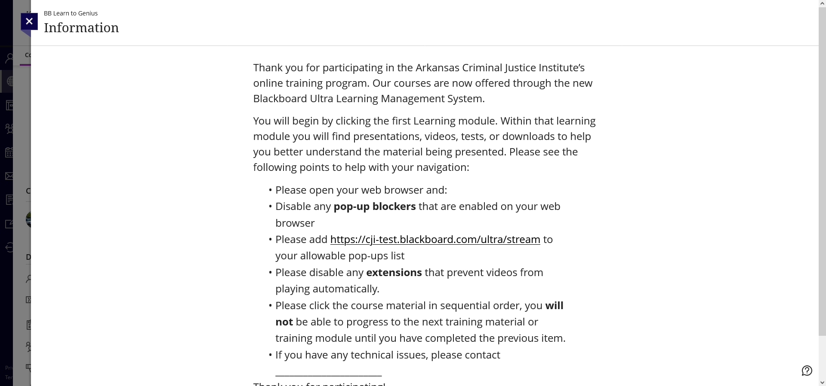
This will take you back to the main class screen with the content list. You will see a green checkmark by the content you have viewed. Go to the next block, expand it to view the additional content and click on that content. You may see a box on the side that provides details about the content – at the bottom it will show a button that says Start attempt 1 (the number will vary depending on the number of attempts). Click on that button to launch the content.
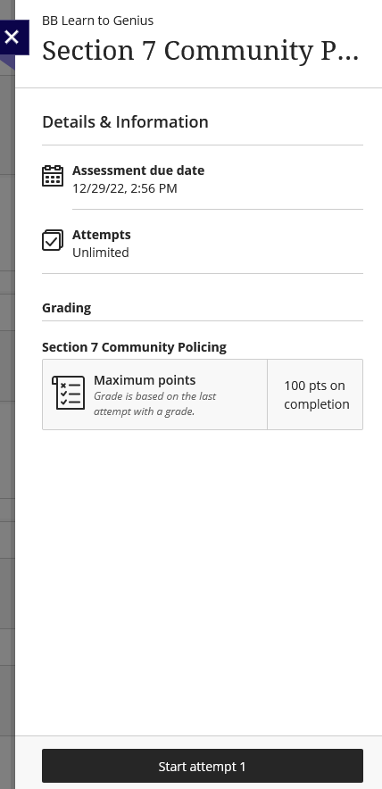
If it’s a presentation, the screen below will pop up in another window. Click on the Play button to start the presentation.
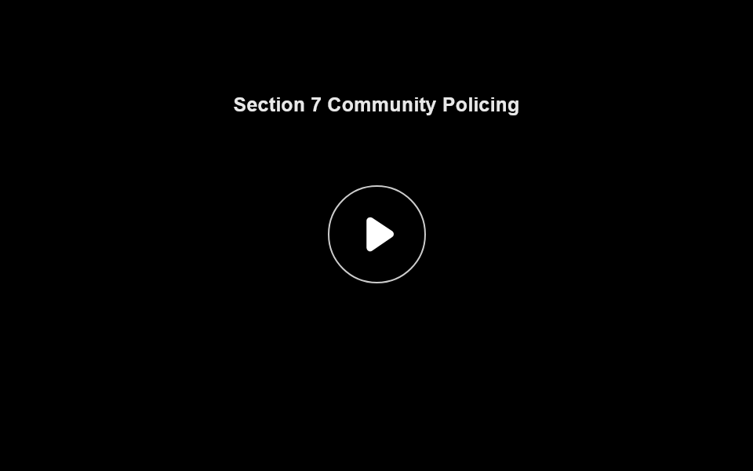
The screen below illustrates the basic layout of most of our classes. The menu shows how many slides there are in each section. The bar beneath the slide allows you to pause or play the audio, start the audio from the beginning, change the volume, turn on or off closed captioning, or change settings. To download course materials, click the RESOURCES button at the top right. The Prev button will take you back to the previous slide and the Next button (when lit up), will take you to the next slide. The Next button will not light up unless the audio/video has finished playing or the slide has been fully explored.
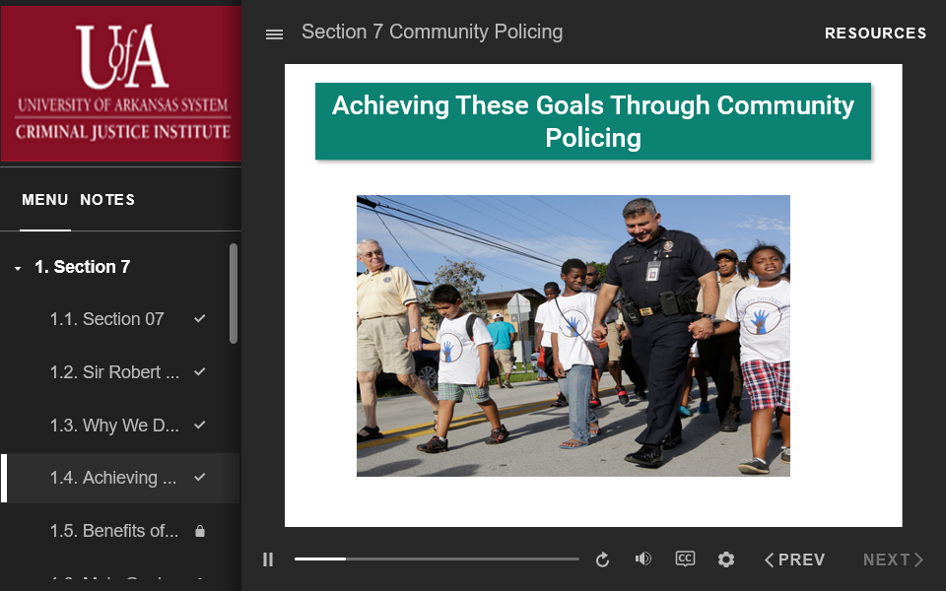
When you have completed all the assignments within the section, close the window. The Blackboard window will change back to the main list of content and the previous section should have a green checkmark by it. The last part of each class is the evaluation - the evaluation is also a graded portion of the class. Once you get to the evaluation make sure you complete it or you will not get credit for the class. Answer each question on the evaluation, when you are done, click the Submit button. You will get another prompt to submit – click on the submit button there.
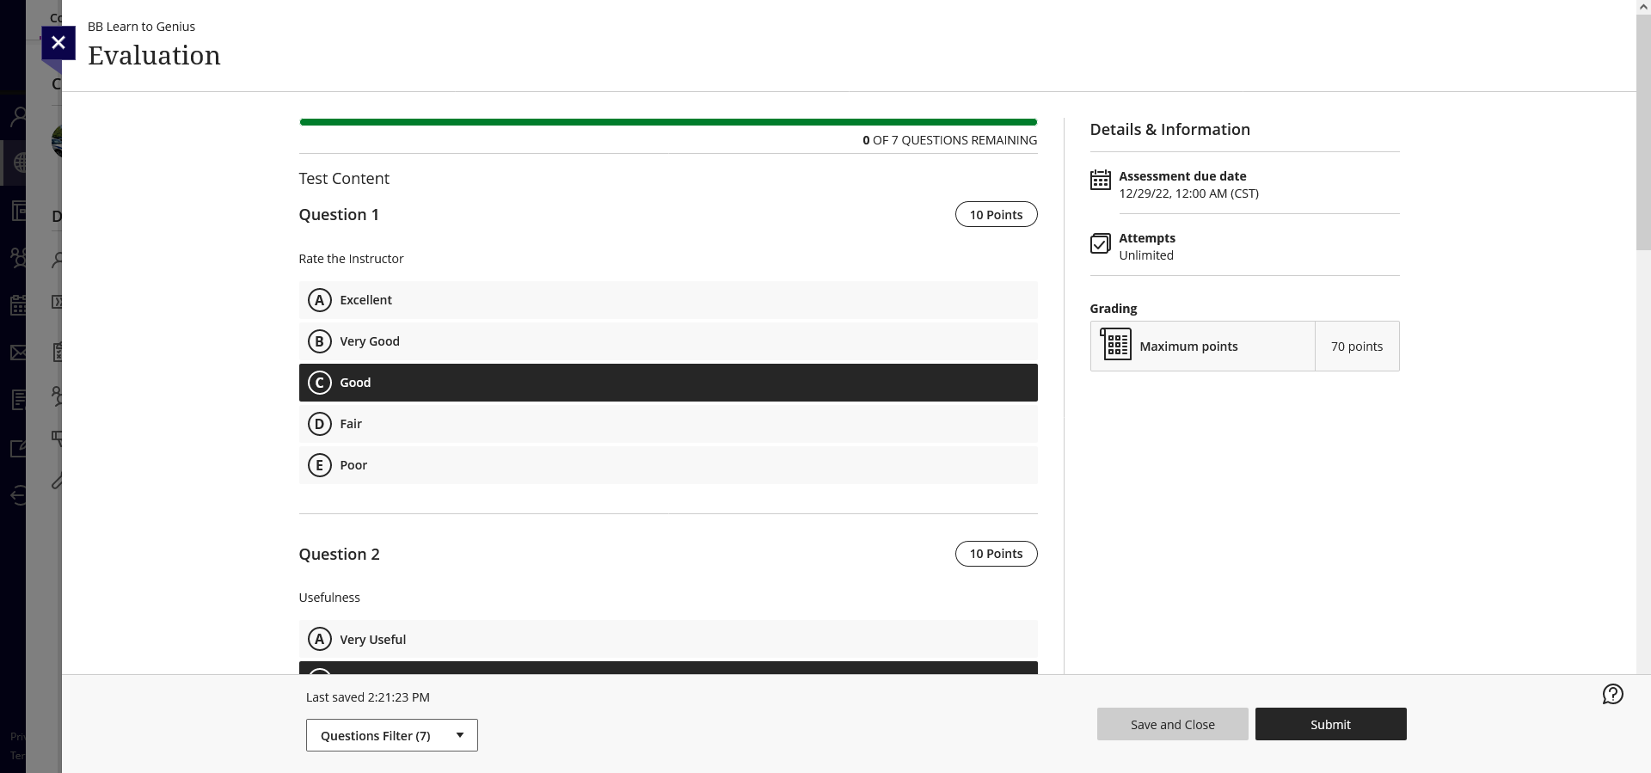
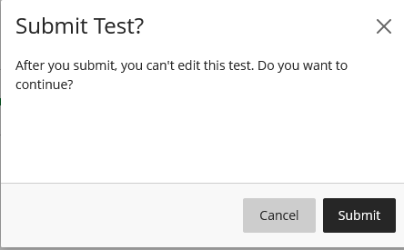
Now click on the X on the left side of the Evaluation window.
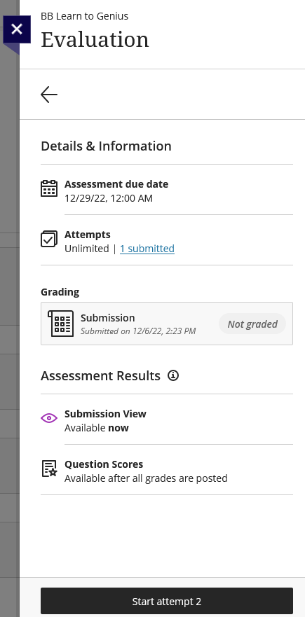
Our staff will need to “grade” the evaluation for the system to recognize it as complete. Once that happens and all other sections are completed, you’ll be able to view and download your certificate in Genius.
To do that, log into Genius and see if your class is listed in the Completed Courses area. It’s possible that you might have to refresh the Active Courses in order to change the status. Once the class is listed in the Completed Courses area, you’ll see an icon by the class name that will allow you to download the certificate.
