The Benefits of Lowering the Per Se BAC Limit from .08% to .05%

By

Sgt. Matthew Cogburn

Garland County Sheriff’s Office

SLES 2025

Table of Contents
Contents Page
Executive Summary 1

Chapter 1:
Introduction 2
How alcohol affects the body 3
First drunk driving laws 4
Vehicle accidents in America – impact of drunk driving 6
What is BAC? 7
Problem Statement – the impact of .08 8

Chapter 2:
Literature review 9
Academic research 10
Government documents 13
Private group/foundation research 14
Standardized Field Sobriety Tests 16
The San Diego Field Study 19
Current laws and policies 20
Proposal for changing the BAC limit 22

Chapter 3:
The argument against lower BAC laws 24
Where does impairment begin? 25
Conclusion 27
References 29
Appendix material 36-50

Executive Summary
Impaired driving is a trend that continues to have an unsafe impact on the interstates, highways, and backroads across the United States. Communities and individuals are both affected by the decisions and actions of impaired drivers. The National Highway Traffic Safety Administration (NHTSA) reports that there are over 110 million cases of impaired driving in the United States each year (Morris, Treloar, Niculete, & McCarthy, 2013). The Fatal Accident Reporting System (FARS) uses three criteria for determining alcohol’s part in traffic crashes. The criteria are alcohol involvement, alcohol test result, and citation for DWI (Zobeck, Grant, Stinson, & Bertolucci, 1994). The prevalence of alcohol in a person’s system who was involved in a fatal traffic crash is higher than it should be. A 2016 NHTSA report showed that alcohol was present in thirty-seven percent (Porath & Beirness, 2019). Although the number of fatal car accidents involving an impaired driver reduced by thirteen percent from 1979 to 1990 (Zobeck, Grant, Stinson, & Bertolucci, 1994); it has since remained steady for quite some time (Morris, Treloar, Niculete, & McCarthy, 2013). This leads one to question, what new efforts can be made to detect and prevent impaired driving in the United States? Since 2000, the legal per se blood alcohol concentration (BAC) has been .08% in the United States. Before this, the per se BAC limit was .10%. This change had some positive impacts on the issue of impaired driving. However, we are still seeing large numbers of injuries and deaths due to drunk drivers. A proposed change of lowering the per se BAC limit from .08% to .05% is a start to continue to make our roadways safer for everyone.

Chapter 1:
Introduction
Safe roadways are a major issue for lawmakers, law enforcement, and the public. The number of traffic signs you see on the side of highways, interstates, and county roads is indicative of how far we have come in making safe roads a priority. From speed limits to traffic lights to public service campaigns, there is great emphasis put on the importance of safe driving in America. Driving a vehicle is a big responsibility for anyone, considering the distractions of other drivers, pedestrians, the time of day, weather, etc. Lawmakers have been creating and implementing laws to help protect drivers on the roadways of America since the early 1900s. New York became the first state to require vehicle owners to register their vehicles in 1901, and by 1920, every state required a license plate on vehicles (“History of traffic,” 2015). William P. Eno, who is also known as the father of traffic safety, helped design roadways and create many traffic safety rules. Eno is the author of the first Rules of Road, which New York City, Paris adopted many of their traffic rules from (“rules of the road: Then versus now,” n.d.).
These early laws were the building blocks of the current laws for our roadways. As more and more people began driving, lawmakers realized that safety laws were a priority. They began implementing laws that were used to protect drivers and pedestrians alike. Throughout the years, most traffic laws have been tweaked, reworded, or changed completely. Speed limits have gone up in some areas, more and more traffic lights and signs are being used today as well, and new laws are proposed during state legislative sessions. The Traffic Safety State Bill Tracking by the National Conference of State Legislatures (NCSL) tracks proposed traffic safety bills from each state. Many states have proposed changes to seatbelts, aggressive driving, distracted driving, and many other areas of concern for driver safety (“Traffic safety state bill tracking,” 2022).

Drunk driving is a major traffic safety concern in America. Major injuries, such as an impaired driver, can cause paralysis, disfigurement, and brain damage. Thousands of people are injured or killed on the interstates, highways, and county roads because of impaired drivers. Additionally, impaired drivers also cause damage to private and public property. Laws have been in place for some time to deter impaired driving, but it is still a very real issue today.
How Alcohol Affects the Body
To understand impairment, you must first understand how alcohol affects the body. Alcohol is in the drug category of central nervous system (CNS) depressants. This is the same drug category that includes barbiturates, antidepressants, non-barbiturates, anti-anxiety, and anti-psychotic drugs. Some examples of these drugs are Xanax, Soma, Valium, etc. A CNS depressant will slow down or depress how the body functions. For example, a person impaired on a CNS depressant may have low blood pressure, low pulse rate, and a lower body temperature. The person may exhibit certain indicators such as droopy eyelids, drowsiness, disoriented, gait ataxia, thick or slurred speech, etc. (“Drug evaluation and classification program, advanced roadside impaired driving enforcement resources,” n.d.).
When alcohol gets into the stomach, twenty percent of it is absorbed through the lining of the stomach directly into the bloodstream, the other eighty percent is absorbed in the small intestine. The effects of alcohol are felt within ten or fifteen minutes (“Alcohol metabolism,” n.d.). Food can slow down the absorption of alcohol by either physically obstructing alcohol from contacting the stomach lining or preventing alcohol from passing through the pyloric valve. Once alcohol is in the bloodstream, it will pass through all the organs in the body.
As alcohol enters the body, it begins to block chemical signals in brain cells (neurons). When this happens, the drinker begins to exhibit the symptoms of intoxication. These symptoms
are impulsive behavior, slurred speech, poor memory, and slowed reflexes, to name a few (Banerjee, 2014). The higher the level of intoxication, the more pronounced the intoxication will become. Impulsive behavior and slowed reflexes are two major symptoms of intoxication that may lead to vehicle crashes. Driving divides the attention of the driver and requires them to focus on multiple tasks at one time. For example, while driving, a person must drive, use turn signals, watch the surrounding traffic, pay attention to traffic signals and signs, etc. Some studies have shown that reaction times are already slowed between .02% and .06% (Effects of alcohol,” n.d.). This means that a driver with a BAC level of .02% or higher would be less likely to respond to a road hazard in an appropriate amount of time to avoid an accident.
First Drunk Driving Laws
One of the first recorded arrests of a person for driving a vehicle while drunk was in 1897 when George Smith, a taxi driver in London, drove his cab into a building while drunk (History.com Editors, 2009). Since then, there have been many laws passed making it illegal to operate a vehicle while impaired. New York passed the first law that made driving a motor vehicle while drunk illegal in 1910 (History.com Editors, 2009). Eventually, all states had laws that prohibited a person from driving a vehicle while intoxicated. In 1938, a BAC of .015% was accepted as the limit for determining if a person was intoxicated while operating a vehicle (“brief history of America’s drunk driving laws,” 2020).
The formation of these laws shows that lawmakers, as well as the public, were becoming aware of the drunk driving problem exceedingly early on. More laws would be passed throughout the years to combat the issue of drunk driving and to help maintain safe roadways. Just as other traffic laws are continuously changing with technology and time, so must impaired driving laws. In the early 1980’s President Ronald Reagan signed an executive order
establishing the Presidential Commission on Drunk Driving. President Reagan cited the number of people killed in motor vehicle crashes involving a drunk driver as a national problem (“Remarks on signing executive order 12358, establishing the Presidential Commission on drunk driving,” n.d.). The goal of the commission was to have state and local agencies acknowledge, review, and crack down on the drunk driving problem in their communities. During this time, states began to raise the legal drinking age from eighteen to twenty-one years of age. Many changes were proposed as well, more than five hundred pieces of legislation that were directed at drunk driving were introduced during the 1983 State legislative sessions. President Reagan acknowledged the difficulty the government faced in the past when trying to pass laws regarding drunk driving. Most notably that states did not like the idea of the federal government forcing them to change their policies. Changes were being made, however, and results were evident in the states that enacted those changes (“Statement on the Presidential Commission on drunk driving,” n.d.).
Continuing with efforts to make driving safer in America, President Bill Clinton signed a bill that created a nationwide legal per se BAC limit of .08%. President Clinton cited the multiple deaths due to impaired drivers as a national concern that must be addressed. The president stated that in 1999, there were over fifteen thousand deaths in alcohol related crashes, with over two thousand of the deaths being children (Welcome to the White House, n.d.). The bill encouraged all states to adopt the legal per se limit at .08% instead of the .10% that was currently accepted by states at that time. Over the years, the issue of drunk driving has become a concern that has caught the attention of politicians, lawmakers, and the public. Efforts to deter impaired drivers and make safer roads for everyone reach from the federal to the local levels.

Vehicle Accidents in America – Impact of Drunk Driving
In 2020, the Hedges Company estimated that there were approximately 289 million vehicles on the roads in America (Davet, 2021). With that many vehicles on America’s roadways, the chances of minor or serious vehicle crashes are high. The National Highway Traffic Safety Administration (NHTSA) stated that in 2012, deaths from vehicle crashes in America were not a top ten cause of death since the early 1980s (National Highway Traffic Safety Administration, n.d.). One reason the numbers may be decreasing is due to the improved safety features of newer vehicles. NHTSA’s Fatality Analysis Reporting System (FARS) found that in 2018, vehicle crash fatalities decreased by over nine hundred from 2017. New and improved safety features in vehicles were cited as a major reason for the decrease (“Newer cars with safety features cited for reduction in highway crash deaths,” 2019).
Vehicle manufacturers have been upgrading safety features in vehicles for an exceptionally long time. The introduction of the airbag in a vehicle was a huge step in driver and passenger safety in vehicles. Since then, more and more safety features have been added to vehicles throughout the years. Features such as blind-spot recognition, lane assistance, and backup cameras have all been used in newer model vehicles. Other safety measures that have been used for years to prevent vehicle crashes are traffic laws. Speed limits, traffic lights, traffic signs, and traffic enforcement by law enforcement are all safety measures put in place to help reduce the number of vehicle crashes, injuries, and deaths on our roadways.
Among those are laws that prohibit operating a vehicle while impaired or intoxicated. Recently, President Joe Biden’s infrastructure plan required car manufacturers to equip new vehicles with alcohol monitoring systems as early as 2026. This safety feature would act like the interlock devices that are installed on vehicles of those convicted of driving while intoxicated
now. However, this feature would be standard and would play a significant role in combating alcohol impaired drivers. While vehicle accidents have long been a leading cause of death in the United States, a fair number of those accidents are alcohol related. The Centers for Disease Control (CDC) found that in 2016, twenty-eight percent of all deaths by vehicle accidents were alcohol related (“Impaired driving: Get the facts,” 2020). The link between alcohol impairment in the number of accidents on our roadways is apparent and should continue to be addressed. While lawmakers continue to address safer roads during legislative sessions, this issue should be a top priority for making roadways safer and reducing the number of deaths and injuries each year on America’s roads.
What is BAC?
Blood alcohol concentration is a measurement of the alcohol concentration in a person’s blood. It is measured by the weight of ethanol in one hundred milliliters (ml) of blood. So, if a person has a BAC of .08%, that means that their blood is .08% alcohol by volume (“Blood alcohol content,” 21). Several factors will impact a person’s BAC level, such as the number of drinks, how fast or slowly the drinks are consumed, the person’s body weight, water composition, enzyme production and levels, sex, medications, and if the person has eaten. Because alcohol is absorbed through the stomach lining and the small intestine, it gets into the bloodstream and travels through every organ in the body. When the alcohol passes through the lungs' air sacs or alveoli, it evaporates as a volatile solution. Therefore, the concentration of alcohol in a person’s breath is equivalent to the concentration of alcohol in their blood. Another way to figure the breath alcohol concentration to the blood alcohol concentration is by using the ratio 2,100:1. Meaning that 2,100 milliliters of alveoli air will have the same amount of alcohol as one milliliter of blood (“Content: The breathalyzer assumes a
specific blood-to-breath ratio to calculate the BAC – The alcohol pharmacology education partnership,” n.d.). If a person is suspected of driving while intoxicated, the law enforcement officer will request a test of the person’s breath to determine their BAC.
A test of a person’s breath, urine, or blood will show how much alcohol is in their blood at the time of the test. Law enforcement officers commonly use breath tests to determine a person’s BAC in DWI arrests. Officers carry preliminary breath tests (PBT) in the field and will also use a BAC machine, such as an Intoximeter, to determine the person’s BAC. The first breath test for alcohol was invented by Professor Rolla Harger in the 1930s. This test collected the person’s breath in a balloon. The breath sample would then be pushed through an acidified potassium permanganate solution. If the person had alcohol on their breath, the solution would change colors. The level of alcohol on the person’s breath would be measured higher if the color change were greater (“Alcohol breathalysers: Early breathalysers,” n.d.). Breathalyzer machines and tests continued to advance throughout the years. BAC test results, along with the clues observed during standardized field sobriety tests, will be used to show impairment in a driver.

Problem Statement – The Impact of .08
Detecting, deterring, and preventing impaired drivers has long been an issue for public safety in America. It is important to remember that drinking and driving is not illegal, but being impaired or intoxicated while driving is. Impaired driving causes deaths, injuries, accidents, and damage to both public and private property. It is estimated by the National Highway Traffic Safety Administration that twenty-eight people die every day because of a drunk driver (“Drunk driving,” n.d.). The total cost of impaired driving is estimated at forty-four billion dollars annually (“Drunk driving,” n.d.). This cost includes medical costs, property damages, and tax dollars for courts.
incarceration, etc. One of the biggest problems with impaired driving, or the prevention of impaired driving, is that there are far more impaired drivers on the roadways than there are police. The Centers for Disease Control (CDC) estimated that over a million drivers were arrested for driving while impaired by alcohol, drugs, or a combination of both (“Impaired driving: Get the facts, “2020).
In 2001, the state of Arkansas changed the legal per se blood alcohol content (BAC) from 0.10 percent to 0.08 percent. This change happened because the BAC limit was becoming standardized across the United States. The change brought a sixteen percent decrease in the proportion of crashes where the drivers were fatally injured and had a BAC of .08 or higher (“U.S. Department of Transportation,” n.d.). Standardizing the legal BAC limit improved safety on interstates, highways, and other roadways. While the current laws are a good start to helping make the roadways safer, there is still plenty that can be done. One change that can help make roadways safer is to lower the per se BAC limit to .05% in every state.
Chapter 2:
Literature Review
Some may view the offense of operating a vehicle while impaired as just a traffic offense, however, impaired driving has a more serious impact than most other traffic offenses. The Arkansas statute for driving or boating while intoxicated (5-65-103) is not under traffic offenses but criminal offenses. There are several reasons why an impaired driving crime is not merely a traffic violation. Impaired driving kills approximately one person every hour in the United States (“Drunk driving,” n.d.). Moreover, impaired driving impacts society in many ways other than just fatal crashes. Damage to public and private property as well as increased insurance costs, are some of the other ways impaired driving affects society.

In 1998, former President Bill Clinton began working on lowering the legal blood alcohol content (BAC) from .10 to .08 to help make the roadways in the United States safer. In 2000, all fifty states had lowered the per se BAC limit to .08. Recently, the state of Utah lowered the legal per se BAC limit from .05 to .08. Many other countries have reduced the legal BAC limit to reduce alcohol related crashes and make roads safer.
This paper will discuss different research and data that conclude the benefits of lowering the BAC limit to .05 from .08. It will also review past policies on impaired driving that were established and some changes to those policies. Finally, the paper will discuss the need for a lower per se BAC limit to make roadways safer and as a general deterrent for impaired drivers.

Academic Research
In 2013 the National Transportation Safety Board (NTSB) published a study that recommended lowering the per se BAC limit from .08 to .05. Researchers James C. Fell and Michael Sherer conducted a study based on the NTSB’s study to contribute to the scientific evidence on whether lowering the BAC limit .05 will be effective in the United States. Fell and Sherer used a meta-analysis to estimate the range and distribution of the most qualifying effects of a reduced BAC limit of .05. The researchers concluded that there is convincing evidence to support the reduction of the current BAC limit from .08 to .05. The data that was examined showed the potential effectiveness of lowering the BAC limit from .08% to .05%. They found that fatal alcohol related crashes decreased by 9.2% when the BAC limit was lowered to .08%. Additionally, the researchers concluded that lowering the BAC limit to .05% would decrease fatal alcohol related crashes by 11.1%, and approximately seventeen hundred lives could be saved
(Fell & Scherer, 2017). The decrease in fatal alcohol related crashes and lives saved is part of the compelling information found in this research.
Researchers James C. Fell and Robert B. Voas examined laboratory studies that showed impairment in critical driving functions begin at lower BAC levels. The researchers also noted that the risk of being involved in a fatal crash is four to ten times more likely when a person’s BAC is between .05% to .07%. The study also examined the .05% BAC in the Netherlands that was implemented in 1974 and found that the lower BAC laws directly impacted a sustained decrease of drunk drivers on the roads. The researchers concluded that lowering the BAC from .08% to .05% will be effective and will serve as a general deterrent to drinking and driving (Fell & Voas, 2006).
Impaired driving has an obvious impact on any country, state, or community where it occurs. Many countries besides the United States have recognized the need for finding ways to address the dangers of impaired driving. In 1998, Austria lowered the per se BAC limit from .08 to .05 to address the problem of impaired driving. Research conducted by the International Council on Alcohol, Drugs, and Traffic Safety showed that within the first month, there was a significant decrease in injuries caused by drunk drivers. There was a ten percent total decrease for injuries caused by drunk drivers in the first year the policy was implemented (Lawrence, n.d)
Researchers J.C. Fell and R.B. Voas found that fourteen different studies conducted after the per se BAC limit was reduced to .08 from .10 showed a five to sixteen percent decrease in alcohol related crashes, injuries, or fatalities. The research also found that studies conducted in labs showed impairment in critical driving functions starts at a lower BAC, and many individuals are significantly impaired by the time their BAC reaches .05 (“Fell & Voas,” 2006).

According to the National Highway Traffic Safety Administration (NHTSA), a driver with a .05 BAC will experience certain levels of impairment. These include exaggerated behavior, loss of small muscle control (unable to focus eyes), impaired judgment, relaxed inhibitions, and lowered alertness (“Drunk driving,” n.d.). Researchers Creaser, Ward, Rakauskas, Shankwitz, and Boer conducted a study on the effects of alcohol on motorcycle drivers. The subjects were given different tasks to complete while consuming alcohol. Four different BAC levels were studied by the researchers during the study. While impairment was evident in subjects that reached a BAC of .08, some also exhibited impairment at a BAC of .05 (Creaser et al., 2009).
Because the level of impairment is a key factor when considering driving while intoxicated offenses, researchers have studied how alcohol affects the body and brain. Different studies and reports have established that impairment can begin when a person’s BAC level is at .05. One of the many indicators of impairment at this level is relaxed inhibitions. This means that a person’s ability to recognize their impairment diminishes the higher their BAC rises. Researchers Solomon, Chamberlain, and Usprich found that impairment may begin the moment a person’s BAC level leaves .00. They also found that while performing the standardized field sobriety tests, several subjects showed significant impairment at a .02 BAC (“About,” 2021). Concluding that operating a vehicle can be dangerous at BAC levels as low as .02 %.
Researchers H. Moskowitz, M. Burns, D. Fiorentino, A. Smiley, and P. Zador reviewed drivers’ characteristics and impairment with various BAC levels. The researchers looked at the driving capabilities of a person at various levels of impairment from 0 to .10% BAC levels. Participants were given divided attention tasks and used a driving simulator during the study. The researchers state that alcohol significantly impaired performance on some measures where the BAC levels were .02% to .10%. While the study did find that performances were impaired at some
level when a person’s BAC was a .02%; it also concluded that by .04% all measures of impairment that are statistically significant were in the direction of degraded performance (Moskowitz et al., 2000).
Government Documents
Data from the National Highway Traffic Safety Administration (NHTSA) shows that twenty-eight people are killed in the United States every day due to impaired drivers. Even though the numbers are lower now than in the early 1980s, over ten thousand people still lost their lives to impaired drivers in 2019 (“Drunk driving, n.d.). Deaths and property damage caused by impaired drivers have a profound impact on the communities they occur in and society as well. In many cases the BAC level of a person involved in a fatal crash is between .01 and .07. This means that impairment will start well before a person reaches the legal per se limit of .08. This also means that the problem of impaired driving needs to be addressed on more levels than just highway safety.
Studies have shown that risky behavior can begin with levels lower than the legal per se limit of .08. Researchers Van Dyke and Fillmore conducted a study based on the National Transportation Safety Board’s recommendations for lowering the legal BAC limit to .05. The researchers concluded that a driver would take more risks the higher their BAC levels are. Therefore, by lowering the legal BAC limit to .05 risk-taking would decrease among drivers (Van Dyke & Fillmore, 2017).
Lowering the BAC limit has many benefits and can decrease the number of impaired drivers on the roadways. Research shows that lowering the BAC limit to .05 can help prevent approximately eleven percent of the accidents caused by impaired drivers (“Utah’s new law against drinking and driving,” n.d.). Researchers Fell and Voas found that drivers with a BAC
of a .05 to .079 were seven to twenty-one times more likely to die in a single vehicle accident than those with a .00 BAC level (“Fell & Voas,” 2006).
Other measures have been used by states to reduce the number of impaired drivers on the roadways. Efforts such as Arkansas House Bill 1062 that increased the look-back period for driving while intoxicated charges (“Arkansas HB1062, 2021, 93rd General Assembly,” n.d.). The bill states that a DWI charge will remain on a person’s record for ten years, meaning that a second or third DWI charge within ten years of the first DWI charge will result in a harsher punishment. The bill also increases the look-back period for fourth, fifth, and sixth DWI charges to twenty years. In Arkansas, a fourth DWI charge is a class D felony punishable by one year in the Arkansas Department of Corrections.
In 2018, the state of Utah lowered the BAC law for intoxicated drivers from .08% to .05%, making it the first state to do so. After the law went into effect, the National Highway Traffic Safety Administration (NHTSA) conducted a study to examine the results of the lower BAC law. NHTSA found that during 2019, the fatal crash rate of Utah decreased by twenty percent. This was a major improvement over the rest of the states, which only saw a six percent decrease in fatal crash rates. NHTSA stated that Utah’s lower BAC limit saved lives and prompted drivers to avoid driving impaired (“Utah’s tougher DUI law cut deaths, study finds,” 2022).
Private Group/Foundation Research
The organization Mothers Against Drunk Driving (MADD) has been a long-time advocate for laws that would deter and prevent impaired driving. In 2019, MADD joined California Senator Jerry Hill in urging the state to lower its BAC limit to .05. MADD stated that through their research and studies, they have found that a lower BAC limit will help reduce
the number of alcohol related fatal accidents on the roadways (“MADD calls for .05 BAC, ignition interlocks for all offenders in California,” n.d.).
Research by The National Academies of Sciences, Engineering, and Medicine found that impairment at a .05 BAC level can have impact a driver’s coordination, ability to track moving objects, difficulty steering, and a reduction in emergency driving responses (“Why lowering the legal limit for drunken driving could make a difference,” n.d.). Researcher, David Jernigan stated that lowering the BAC limit can save up to fifteen hundred lives a year. Jernigan also suggested other measures to help deter impaired driving. The suggested measures included increased alcohol taxes, reducing the sale and availability of alcohol, changing how alcohol is showing a greater presence of enforcement through sobriety checkpoints, mandating that all who are convicted of driving while impaired have ignition interlocks installed, altering how DWI cases are treated in the court system, promoting treatment for those who abuse substances, providing alternative transportation, and creating a noninvasive, in-vehicle technology that prevents drivers from driving when their BAC is too high (Esser et al., 2016).

Standardized Field Sobriety Testing
In the preliminary stages of DWI detection, law enforcement officers used many different tests to assess a person’s level of intoxication. None of these tests were validated, and the tests a state trooper in Florida used would be completely different than what a state trooper in Arkansas would use. The National Highway Traffic Safety Administration saw the need to develop a standardized system for officers to use for detecting DWIs. In the mid-1970s, NHTSA began research with the Southern California Research Institute (SCRI) to determine which field sobriety tests were the most accurate in identifying impairment in drivers. There were three reports published by the SCRI: the California: 1977 (lab), the California: 1981 (lab and field), and Maryland, District of Columbia, Virginia, North Carolina: 1983 (field). During the study, six tests were used during the initial stage of the study. They included the One Leg Stand test, the Finger-to-Nose test, the Finger Count test, the Walk and Turn test, the Tracing test (which was given with a pencil and paper), and the Nystagmus test. The study found that three tests, when given in a specific manner, were the most accurate. Those three tests were the horizontal gaze nystagmus (HGN) test, walk and turn (WAT), and the one-leg stand (OLS) test. These three tests were found to be exceptionally reliable in distinguishing BAC levels at a .10% or higher when used (NHTSA National Highway Traffic Safety Administration, n.d.).
The HGN, WAT, and OLS tests became the only tests that have been validated through numerous studies. The tests are now referred to as the standardized field sobriety tests or SFSTs. While the other tests that were used were valid, it was determined that they were just reassessing the same skills that the three validated tests were assessing. Out of the three validated tests, the HGN test is the most reliable. The laboratory tests found that the HGN test alone was
seventy-seven percent accurate by itself, the WAT test was sixty-eight percent accurate by itself, and the OLS test was sixty-five percent accurate by itself.
The SFSTs are given in a particular order, the instructions are given the same way every time, and this cannot be deviated from. The order the tests are given is HGN, WAT, then OLS. Officers are trained to give specific instructions and what clues are validated and can be used in determining impairment. In the first test, HGN, officers examine the eyes of the subject. Nystagmus is defined as the involuntary jerking of the eyes. Horizontal gaze nystagmus (HGN) is defined as the involuntary jerking of the eyes when the gaze is directed to the side. There are three validated clues for each eye in the HGN test. The first is a lack of smooth pursuit, as the officer moves the stimulus from left to right in front of the subject’s face, they will observe if the eyes follow the stimulus smoothly or not. Think of windshield wipers as they go back and forth; if there is rain on the windshield, the wipers move smoothly. However, if the windshield is dry, the wipers will jump and bounce as they move across the windshield. This is how a lack of smooth pursuit looks when it is observed by the officer. The second clue is distinct and sustained nystagmus at maximum deviation. The officer will hold the stimulus (a finger) far out to the left and right side of the subject’s face and instruct the subject to stare at the stimulus. The officer is looking for a distinct and sustained involuntary jerking of the eyes as they gaze at the stimulus. The office will hold the stimulus out for a minimum of four seconds but no longer than thirty seconds as not to fatigue the eye. The final clue for the HGN test is the onset of nystagmus prior to forty-five degrees. This clue is observed as the officer passes the stimulus slowly from the center of the subject’s nose to about the edge of the left and right shoulders of the subject. During the pass, the officer is looking for involuntary jerking of the eyes as they track the stimulus. With higher levels of impairment, the nystagmus will be observable sooner than with lower levels. If an
officer observes four out of the six total clues of the HGN, there is an eighty-eight percent chance the driver’s BAC is a .08% or higher (“DWI detection and standardized field sobriety test (SFST) resources” n.d.).
The WAT and OLS tests begin the divided attention portion of the SFSTs. Officers use the clues observed in these two tests to assess the driver’s ability to divide their attention. This is important because driving a vehicle requires the driver to divide their attention to successfully operate the vehicle. The WAT test has a total of eight validated clues that may be observed. The first two clues are observed during the instructional stage of the test. This is when the officer is giving the subject instructions on how to stand and what to do during the test. In this stage, it is a clue if the person loses their balance or attempts to start the test before being instructed by the officer. The second stage of the WAT test is the walking stage. During this stage, the officer observes the subject as he or she walks a straight line, taking nine heel-to-toe steps up and then back down the line. The clues that can be observed in this stage are using arms for balance, missing heel to toe, stopping while walking, stepping off the line, making an improper turn, and taking an incorrect number of steps. If an officer observes two out of the eight clues in the WAT test, they can accurately classify seventy-nine percent of drivers at a .08% BAC or higher (“DWI detection and standardized field sobriety test (SFST) resources” n.d.).
The final test of the SFSTs and the second divided attention test is the OLS test. This test also has two stages, the instructional stage and the balance and counting stage. During this test, subjects are instructed to lift one foot in the air approximately six inches off the ground, keeping parallel to the ground while counting in a prescribed manner. This test has four validated clues, and they are putting foot down, using arms to balance, swaying, and hopping. If the officer observes two out of the four clues, they can accurately classify eighty-three percent of the people tested at
a.08 % or higher. It should be noted that SFSTs are not pass or fail tests; the tests are designed for the officer to observe clues and make a proper arrest/do not arrest decision based on those clues (“DWI detection and standardized field sobriety test (SFST) resources,” n.d.).
The SFSTs are now the only validated battery of tests used across the United States to detect intoxicated drivers (“DWI detection and standardized field sobriety test (SFST) resources” n.d.). This now means that the same tests are performed the same way and in the same order by all law enforcement officers in the United States. There are two other levels of training for officers to go through to help identify impaired drivers. They are the Advanced Roadside Impaired Driving Enforcement (ARIDE) and the Drug Recognition Expert (DRE) program. However, these two programs delve deeper into the drug impairment than alcohol impairment.
The San Diego Field Study
Even though there were lab studies and research that helped identify the HGN, WAT, and OLS tests as the most accurate and reliable tests to detect impairment, the tests were subjected to field validation studies. This study was conducted when there was a push to lower the BAC limit from .10% to .08% (“Concepts and principles of the standardized field sobriety tests,” 2021). This study examined the accuracy of the officer’s arrest/do not arrest decision after completing all three phases of DWI detection and questioned if the SFSTs discriminated at BACs lower than .10%. The three phases of detection are vehicle in motion, personal contact, and the pre-arrest screening. The study assessed whether, after completing all three phases of the DWI detection, the officer made a correct decision to arrest the subject and the subject had a BAC above the legal limit, or the officer made a correct decision in releasing the subject and the subject tested below the legal BAC limit. This study showed that officers
correct arrest decisions were made based on the clues observed in the three SFST tests (“Concepts and principles of the standardized field sobriety tests,” 2021).
Current Laws and Policies
Laws that are made for intoxicated driving are punitive and attempt to deter the infraction from being committed. Some forms of punishment for intoxicated driving are arrest, jail time, fines, loss of driver’s license, and mandated alcohol education classes. The reality of punishment combined with other efforts, such as public service announcements and prevention programs, are used to increase awareness and deterrence. By the year 2000, most states had lowered the BAC limit to .08% from .10%. Louisiana was the last state to adopt the .08% per se limit for alcohol impaired drivers. Today, the per se limit for BAC in forty-nine states is .08%. Utah is the first state to adopt a lower per se limit for BAC at .05%. Arkansas criminal code, 5-65-103, is the state’s driving while intoxicated (DWI) law. The law states that it is unlawful and punishable for any person who is intoxicated to operate or be in actual physical control of a vehicle; and it unlawful and punishable for any person to operate or be in physical control of a vehicle if at the time the alcohol concentration in the person’s breath or blood was eight-hundredths or more based upon the definition of breath, blood, and urine concentration in 5-65-204 (“2010 Arkansas code:: Title 5 – Criminal Offenses:: Subtitle 6 – offenses against public health, safety, or welfare:: Chapter 65 – Driving while intoxicated:: Subchapter 1 – General provisions:: 5-65-103 – Unlawful acts,” n.d.). A person who is convicted of four DWIs in a matter of ten years will face felony charges that may result in a one-year sentence to the Arkansas Department of Corrections. DWI first, second, and third are all unclassified misdemeanor charges but carry different bonds and harsher sentences for each consecutive offense. The bond for each ranges from one thousand to twenty-five hundred dollars.

Arkansas laws also have specifications for underage driving under the influence (DUI), as well as specifications for driving while intoxicated in a commercial vehicle. For anyone under the age of twenty-one, the legal per se limit is between .02% and .08%. If a person under the age of twenty-one has a BAC over .08%, the charge is DWI instead of underage DUI. For commercial drivers, the legal per se BAC limit is .04% however, the driver must be operating a commercial vehicle for the .04% BAC to apply. If a person with a commercial driver's license (CDL) is operating or in actual physical control of a non-commercial vehicle, then the .08% BAC applies. Even though the per se limit is .08% for anyone twenty-one years or older who is operating a non-commercial vehicle, if a law enforcement officer can articulate impairment in the driver but their BAC is between .04% to .079%, the officer can still charge them with DWI. In cases such as this, the prosecutor and law enforcement officer must have sufficient evidence to support the impairment instead of relying solely on the BAC level of the driver.
Arkansas also has what is known as the implied consent law. This law states that anyone who operates or is in actual physical control of a vehicle is deemed to have given consent to one or more chemical tests of their breath, saliva, or urine to determine the alcohol or controlled substance content of their breath or blood. A person can refuse to take a chemical test, but will be subjected to penalties provided by law, which include the suspension or revocation of their driver’s license. Refusing to submit to a chemical test is a separate charge that will be applied to anyone who does not provide a sample of their breath, saliva, or urine. In some jurisdictions, if a person refuses to take a chemical test, the officer may be required to get a warrant for the person’s blood. In other jurisdictions, the person will simply be charged with the DWI as well as refusal to
submit to chemical testing. The Arkansas criminal code for refusal to submit to chemical testing is 5-65-205; it is an unclassified misdemeanor and does not have a bond associated with it.
Proposal for Changing the Limit from .08% to .05%
The policy change that this paper proposes is reducing the legal per se BAC limit from .08% to .05%. This proposal aims to reduce the number of deaths, accidents, injuries, and property damages that are caused by drunk or impaired drivers across the state. Additionally, the proposal would seek to reduce the number of intoxicated drivers on the roadways. Consider the reduction of total deaths in vehicle accidents with alcohol involved when the legal per se BAC limit dropped to .08% from .10%. Mothers Against Drunk Driving (MADD) reported that when the BAC limit was dropped to .08%, there was a 9.2 percent reduction in fatal alcohol related crashes (“problem,” n.d.). Given this information, it is hoped that reducing the per se BAC limit to .05% will further reduce the number of fatal alcohol related crashes in the future.
There are several other factors when considering the reasons to lower the BAC limit to .05%. According to NHTSA, the average annual cost of alcohol related crashes is 44 billion dollars (“Drunk driving,” n.d.). Mothers Against Drunk Driving has estimated that by lowering the per se BAC limit to .05%, the number of lives saved would range from five hundred and thirty-eight to one thousand seven hundred and ninety annually. Furthermore, alcohol related fatalities would decrease by eleven percent. The goal of this policy proposal is to reduce the number of deaths, accidents, and total costs that are a result of alcohol impaired drivers. As well as increasing the safety for drivers on America’s roadways.
If passed, the law would state that is unlawful and punishable for any person who is intoxicated or under the influence of alcohol, controlled substance, or any other intoxicant that would render a person unable to operate a vehicle safely. It is also unlawful and
punishable provided in the act for any person to operate or be in physical control of a motorboat on the waters of this state or a motor vehicle if at any time the alcohol concentration in the person’s breath or blood was five hundredths (0.05%) or more based upon the definition of breath, blood, and urine concentration. Alcohol concentration in the blood shall be based upon grams of alcohol per one hundred milliliters of blood, and alcohol concentration in the breath shall be based upon grams of alcohol per 210 liters of breath.
One part of the law that law enforcement officers and prosecutors should pay especially close attention to is what is “actual physical control?” Currently, Arkansas criminal code 5-65-103, which is the state’s driving while intoxicated law, does not define what actual physical control of a vehicle is. However, there have been cases in the state where the Arkansas Supreme Court has ruled on what constitutes actual physical control. Two separate cases that were brought to the Arkansas Supreme Court were reviewed if the trial court erred in finding the driver in actual physical control of the vehicle. In Stephenson vs. The City of Fort Smith, the defendant was found passed out behind the steering wheel of his vehicle, the vehicle was not running, and the keys were not in the ignition but on the dashboard of the vehicle. In a similar case, Dowell vs. Arkansas, the particulars were almost identical except for the location of the keys. The court ruled that neither defendant could be found in actual physical control because their vehicles were not running and the keys were not in the ignition (“Findlaw’s Court of Appeals of Arkansas case and opinions,” n.d.). This portion of the law is vital to an agency’s policy on DWI arrests. Law enforcement officers must understand the definition of actual physical control before making an arrest decision.
An agency policy should have a clear statement of what the impaired driving law is and what is expected from the officer during a DWI investigation. During standardized field sobriety
training officers are taught the three phases of DWI detection. Those phases are vehicle in motion, personal contact, and the pre-arrest screening. An agency's policy should encompass all stages to help officers when making the arrest/do not arrest decision. The purpose of the policy is to detect, deter, and remove impaired drivers from the roadways to make them safer for the public. If an officer has reasonable cause to believe that a driver of a vehicle is impaired or under the influence, the officer shall take the necessary steps to determine the impairment or intoxication of the driver. This includes but is not limited to administering the standardized field sobriety tests (SFSTs) and checking the driver’s BAC via a preliminary breath test only after completing the SFSTs. If, in the process of the investigation, the officer has a reasonable cause to believe the person is under the influence, he or she shall arrest the driver and continue the investigation. The officer must read the driver the Arkansas Implied Consent Law and have the driver agree to a chemical test of his or her breath, saliva, or urine before administering a chemical test to determine the alcohol content of the driver’s breath or blood. If the driver has a BAC of .05 or more, the officer shall charge the driver with driving while intoxicated and check the driver’s criminal history for prior DWI charges. The officer shall then complete all necessary paperwork and traffic citations.

Chapter 3:
The Argument Against Lower BAC Laws
However, there are concerns about the unintended consequences of lowering the BAC limit. One major concern voiced by the American Beverage Institute (ABI) is the criminalization of drivers and higher arrest rates. Consider that the Arkansas criminal statute
does not say it is illegal to drink alcohol and drive; it states that it is illegal for a person who is intoxicated to operate or be in actual physical control of a vehicle. If it is not illegal to drink and drive, then many people may have a drink or two and still drive because their BAC would not be over the .08%. The ABI believes that by lowering the BAC limit, states will begin to punish those who do drink responsibly and waste resources arresting them (“Lowering the blood-alcohol arrest level,” 2020).
Another argument the ABI makes is how body size and sex impact how fast a person reaches certain BAC levels. A chart used by the ABI shows that a one-hundred-and-sixty-pound woman would reach a BAC level of .06% after two drinks. A man at the same weight would be right at the .05% with two drinks and at a .07% after three drinks (“Lowering the blood-alcohol arrest level,” 2020). The ABI also argues that most accidents involving alcohol have drivers who are well over the current legal limit of .08%. They even argue that a person with a BAC level of .05% is less dangerous than a person who is talking on a cell phone while driving (“Viewpoint: Bill to lower legal blood-alcohol limit is political theater,” 2020). Another concern is that lawmakers should be going after repeat offenders and making harsher laws for those who operate a vehicle at high BAC levels. While these arguments are valid, there are plenty of ways to drink responsibly and still not drive a vehicle. Drinkers are encouraged to use Uber, taxi services, or a designated driver to prevent them from getting behind the wheel.

Where Does Impairment Begin?
The question for this policy proposal is not if intoxicated people should drive vehicles; they should not, but where does the impairment start? Alcohol impairs the mental and physical capacities of a person. It is a central nervous system depressant that relaxes
inhibitions may lead to poor judgment by the drinker. Impairment is defined as a state of being impaired; some synonyms for impairment are condition, disorder, disablement, and defect. Understanding what level of alcohol will begin to affect a person is imperative. The level of a person’s impairment depends on the amount of alcohol in the person’s blood. As previously discussed, the blood alcohol concentration in a person is what is measured when identifying impairment.
Different effects are felt at distinct levels of BAC in a person. At .02 to .039%, a person may feel relaxed, and their inhibitions will begin to loosen. Coordination is not necessarily impacted at this point. Between .04 to .059%, a person will continue to feel relaxed, their inhibitions will continue to loosen, they will begin to experience impairment of memory, and judgment and self-control will begin to decrease. At .06 to .099%, coordination begins to be affected, and vision, speech, and reaction time are all impaired at these levels. As the BAC increases, more significant indicators will be present. Such as a loss of gross motor skills, loss of balance, blurred vision, drowsiness, etc. (“Blood alcohol content,” 21). Even though the impairment level increases, there is still some impairment at lower levels that may impact a person’s ability to operate a vehicle safely.
A person may not feel impairment, but that does not mean it will not have some sort of impact on them. This is especially important when we are talking about impaired driving. When reviewing capabilities and impairment, researchers H. Moskowitz, M. Burns, D. Fiorentino, A. Smiley, and P. Zador noted that some drivers show significant impairment at BAC levels around .02%. They also noted that by .04% BAC, all measures of impairment that are statistically significant were in the direction of degraded performance (Moskowitz et al., 2000). Other research has shown that operating a vehicle at BAC levels as low as .02% can be dangerous
(“About,” 2021). This information is a crucial factor when considering driver safety and a legal BAC limit.
Conclusion
The safety of drivers and passengers on America’s roadways is an important nationwide issue. Vehicle crashes are among the leading causes of death in our country, and we should continue to focus on ways to improve the overall safety of the roadways. Combating drunk driving is a great place to start when considering safer roads in America. Several studies and researchers have concluded that lowering the legal BAC limit saves lives, money, and property. Additionally, studies found that impairment begins well below the current legal BAC limit of .08% that most of our states have in place now. Research continues to show that a driver’s abilities to respond to normal driving situations diminish when their BAC level is .05 to .079. These findings show that impairment at certain levels creates a substantial risk of vehicle crashes, injuries, and sometimes death when an impaired person operates a vehicle. With this information policy policymakers should be able to appreciate the benefits of lowering the BAC limit from .08 to .05.
There are many ways to make driving safer. Vehicle manufacturers continue to make strides in safety features. Lawmakers examine and pass new laws during legislative sessions that are aimed at roadway safety. This policy change can impact many lives, and although it does come with some negative effects, it has many positives as well. Injuries and deaths from alcohol related crashes are very preventable. It only requires lawmakers to review the evidence and make the necessary changes that will increase safety on our roadways. This approach may well garner some negative attention but, how many deaths and injuries must happen for the positive to outweigh the negative.

In the book Left of the Bang by Patrick Van Horne and Jason A. Riley, the authors use the term left of the bang to describe the importance of being aware and prepared before a violent incident occurs. Using a timeline where the middle is the “bang,” everything to the left of it happens before the incident, and to the right happens after. Horne and Riley describe being left of the bang as being proactive and preparing for an incident (Horne & Riley, 2014). In this case, deaths and injuries are the “bang,” and the lower BAC law is dealing with the problem “left of the bang.” Decreasing the legal BAC limit to .05% is a proactive approach to reducing the number of deaths, injuries, and impaired drivers on our roadways. Even though it will not eliminate intoxicated drivers, it will bring awareness to the issue and may help promote the idea of responsible drinking.

References
About. (2021, March 8). HeinOnline. https://heinonline.org/HOL/LandingPage?handle=hein.journals/clwqrty52&div=10&id=&page=
Creaser, J. I., Ward, N. J., Rakauskas, M. E., Shankwitz, C., & Boer, E. R. (2009). Effects of alcohol impairment on motorcycle riding skills. Accident Analysis & Prevention, 41(5), 906-913. https://doi.org/10.1016/j.aap.2009.04.007
Fell, J. C., & Voas, R. B. (2006). The effectiveness of reducing illegal blood alcohol concentration (BAC) limits for driving: Evidence for lowering the limit to .05 BAC. Journal of Safety Research, 37(3), 233-243. https://doi.org/10.1016/j.jsr.2005.07.006
Drunk driving. (n.d.). NHTSA | National Highway Traffic Safety Administration. https://www.nhtsa.gov/risky-driving/drunk-driving
Drunk driving. (n.d.). NHTSA | National Highway Traffic Safety Administration. https://www.nhtsa.gov/risky-driving/drunk-driving
Fell, J. C., & Scherer, M. (2017). Estimation of the potential effectiveness of lowering the blood alcohol concentration (BAC) limit for driving from 0.08 to 0.05 grams per deciliter in the United States. Alcoholism: Clinical and Experimental Research, 41(12), 2128-2139. https://doi.org/10.1111/acer.13501
Fell, J. C., & Voas, R. B. (2006). The effectiveness of reducing illegal blood alcohol concentration (BAC) limits for driving: Evidence for lowering the limit to .05 BAC. Journal of Safety Research, 37(3), 233-243. https://doi.org/10.1016/j.jsr.2005.07.006

Lawrence, D. (n.d.). SafetyLit: Effects of lowering the legal BAC limit in Austria. SafetyLit: Injury Research and Prevention Literature Update. https://www.safetylit.org/citations/index.php?fuseaction=citations.viewdetails&citationIds[]=citjournalarticle_246851_38
2017 Arkansas code: Title 5 - Criminal offenses: Subtitle 6 - Offenses against public health, safety, or welfare: Chapter 65 - Driving or boating while intoxicated: SubChapter 1 - General provisions: § 5-65-103. Driving or boating while intoxicated. (n.d.). Justia Law. https://law.justia.com/codes/arkansas/2017/title-5/subtitle-6/chapter-65/subchapter-1/section-5-65-103/
Arkansas HB1062 | 2021 | 93rd General Assembly. (n.d.). LegiScan. https://legiscan.com/AR/bill/HB1062/2021
MADD calls for .05 BAC, ignition interlocks for all offenders in California. (n.d.). MADD. https://www.madd.org/press-release/madd-calls-for-05-bac-ignition-interlocks-for-all-offenders-in-california
Utah’s new law against drinking and driving. (n.d.). Institute for Health Policy and Leadership. https://ihpl.llu.edu/blog/utah-s-new-law-against-drinking-and-driving
Van Dyke, N. A., & Fillmore, M. T. (2017). Laboratory analysis of risky driving at 0.05% and 0.08% blood alcohol concentration. Drug and Alcohol Dependence, 175, 127-132. https://doi.org/10.1016/j.drugalcdep.2017.02.005
Why lowering the legal limit for drunken driving could actually make a difference? (n.d.). abc10.com. https://www.abc10.com/article/news/why-lowering-the-legal-limit-for-drunk-driving-could-make-a-difference/103-6fb5d012-0fb5-436d-8b7c-c221e7aa46cf

Esser, M. B., Bao, J., Jernigan, D. H., & Hyder, A. A. (2016). Evaluation of the evidence base for the alcohol industry’s actions to reduce drink driving globally. American Journal of Public Health, 106(4), 707-713. https://doi.org/10.2105/ajph.2015.303026
ZOBECK, T. S., GRANT, B. F., STINSON, F. S., & BERTOLUCCI, D. (1994). Alcohol involvement in fatal traffic crashes in the United States: 1979-90. Addiction, 89(2), 227-231.
Morris, D. H., Treloar, H. R., Niculete, M. E., & McCarthy, D. M. (2013). Perceived danger while intoxicated uniquely contributes to driving after drinking. Alcoholism: Clinical and Experimental Research, 38(2), 521-528.
A brief history of America's drunk driving laws. (2020, May 12). DWI Springfield. https://www.dwispringfield.com/blog/a-brief-history-of-americas-drunk-driving-laws
The history of traffic. (2015, February 26). Comedy Traffic School®. https://www.comedytrafficschool.com/the-history-of-traffic
History.com Editors. (2009, November 24). First drunk driving arrest. HISTORY. https://www.history.com/this-day-in-history/first-drunk-driving-arrest
Remarks on signing executive order 12358, establishing the Presidential Commission on drunk driving. (n.d.). Ronald Reagan. https://www.reaganlibrary.gov/archives/speech/remarks-signing-executive-order-12358-establishing-presidential-commission-drunk
The rules of the road: Then versus now. (n.d.). https://www.enotrans.org/article/the-rules-of-the-road-then-versus-now

Statement on the Presidential Commission on drunk driving. (n.d.). Ronald Reagan. https://www.reaganlibrary.gov/archives/speech/statement-presidential-commission-drunk-driving
Traffic safety state bill tracking. (2022, March 16). Legislative News, Studies, and Analysis | National Conference of State Legislatures. https://www.ncsl.org/research/transportation/state-traffic-safety-legislation-database.aspx
(n.d.). Welcome To the White House. https://clintonwhitehouse5.archives.gov/
2010 Arkansas code: Title 5 - Criminal offenses: Subtitle 6 - Offenses against public health, safety, or welfare: Chapter 65 - Driving while intoxicated: SubChapter 1 - General provisions: § 5-65-103 - Unlawful acts. (n.d.). Justia Law. https://law.justia.com/codes/arkansas/2010/title-5/subthttps://www.drinkdriving.org/drink_driving_information_breathalysers_early.phpitle-6/chapter-65/subchapter-1/5-65-103
Alcohol breathalysers: Early breathalysers. (n.d.). Drink Driving, Have You Been Caught? – Drinkdriving.org.
Alcohol metabolism. (n.d.). Bowling Green State University. https://www.bgsu.edu/recwell/wellness-connection/alcohol-education/alcohol-metabolism.html
Banerjee, N. (2014). Neurotransmitters in alcoholism: A review of neurobiological and genetic studies. Indian Journal of Human Genetics, 20(1), 20. https://doi.org/10.4103/0971-6866.132750

Blood alcohol content. (21, November 9). https://www.utoledo.edu/studentaffairs/counseling/selfhelp/substanceuse/bac.html
Concepts and principles of the standardized Field sobriety tests. (2021, October 16). Justia. https://www.justia.com/criminal/drunk-driving-dui-dwi/docs/standardized-field-sobriety-tests/
Content: The breathalyzer assumes a specific blood-to-Breath-Ratio to calculate the BAC – The alcohol pharmacology education partnership. (n.d.). Sites@Duke Express | sites.duke.edu. https://sites.duke.edu/apep/module-4-alcohol-and-the-breathalyzer-test/content-the-breathalyzer-assumes-a-specific-blood-to-breath-ratio-to-cal
Davet, B. (2021, June 24). US VIO vehicle registration statistics: See how many cars in the US. Hedges & Company. https://hedgescompany.com/automotive-market-research-statistics/auto-mailing-lists-and-marketing/
Drug evaluation and classification program, advanced roadside impaired driving enforcement resources. (n.d.). NHTSA. https://www.nhtsa.gov/enforcement-justice-services/drug-evaluation-and-classification-program-advanced-roadside-impaired
Drunk driving. (n.d.). NHTSA | National Highway Traffic Safety Administration. https://www.nhtsa.gov/risky-driving/drunk-driving
Effects of alcohol. (n.d.). TAC - Transport Accident Commission - TAC - Transport Accident Commission. https://www.tac.vic.gov.au/road-safety/statistics/summaries/drink-driving-statistics/effects-of-alcohol
Impaired driving: Get the facts. (2020, November 6). Centers for Disease Control and Prevention. https://www.cdc.gov/transportationsafety/impaired_driving/impaired-drv_factsheet.html

Lowering the blood-alcohol arrest level. (2020, January 30). American Beverage Institute. https://abionline.org/issue/lowering-the-blood-alcohol-arrest-level/
Marketing Communications: Web // University of Notre Dame. (n.d.). Blood alcohol concentration // rev. James E. McDonald, C.S.C., center for student well-being // University of Notre Dame. Rev. James E. McDonald, C.S.C., Center for Student Well-Being. https://mcwell.nd.edu/your-well-being/physical-well-being/alcohol/blood-alcohol-concentration/
Moskowitz, H., Burns, M., Fiorentino, D., Smiley, A., & Zador, P. (2000). Driver characteristics and impairment at various BACs. PsycEXTRA Dataset. https://doi.org/10.1037/e440362008-001
National Highway Traffic Safety Administration. (n.d.). {{PageFactory.title}}. https://crashstats.nhtsa.dot.gov/
Newer cars with safety features cited for reduction in highway crash deaths. (2019, October 23). Insurance Journal. https://www.insurancejournal.com/news/national/2019/10/23/546358.htm
(n.d.). NHTSA | National Highway Traffic Safety Administration. https://www.nhtsa.gov/sites/nhtsa.gov
The problem. (n.d.). MADD. https://www.madd.org/the-problem/#drunkdriving
Viewpoint: Bill to lower legal blood-alcohol limit is political theater. (2021, June 7). American Beverage Institute. https://abionline.org/op-ed/viewpoint-bill-to-lower-legal-blood-alcohol-limit-is-political-theater/
Fell, J. C., & Scherer, M. (2017). Estimation of the potential effectiveness of lowering the blood alcohol concentration (BAC) limit for driving from 0.08 to 0.05 grams per deciliter in

the United States. Alcoholism: Clinical and Experimental Research, 41(12), 2128-2139. https://doi.org/10.1111/acer.13501
FindLaw's Court of Appeals of Arkansas case and opinions. (n.d.). Findlaw. https://caselaw.findlaw.com/ar-court-of-appeals/1171579.html
Horne, P. V., & Riley, J. (2014). Left of bang: How the Marine Corps' combat hunter program can save your life.
Utah's tougher DUI law cut deaths; study finds. (2022, February 14). The Pew Charitable Trusts | The Pew Charitable Trusts. https://www.pewtrusts.org/en/research-and-analysis/blogs/stateline/2022/02/14/utahs-tougher-dui-law-cut-deaths-study-finds
DWI detection and standardized Field sobriety test (SFST) resources. (n.d.). NHTSA. https://www.nhtsa.gov/dwi-detection-and-standardized-field-sobriety-test-sfst-resources

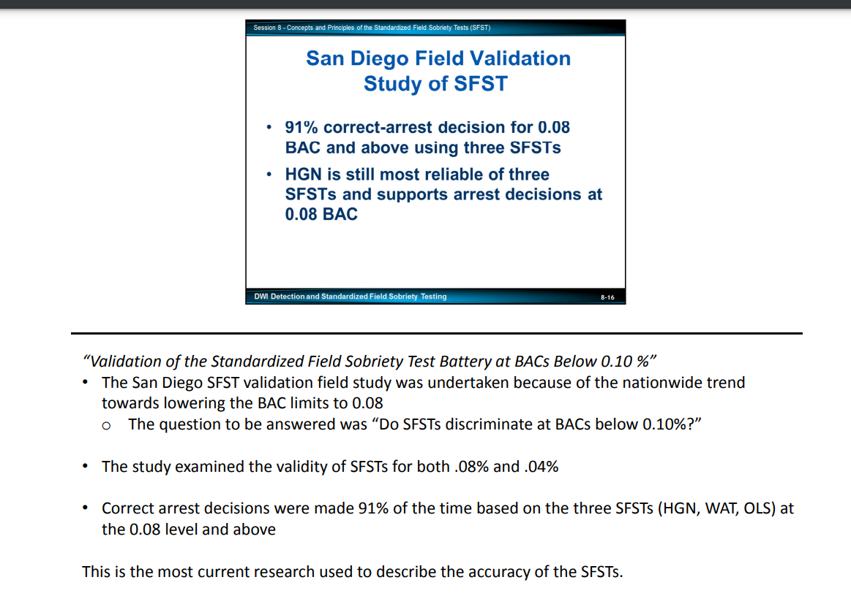
Appendix A

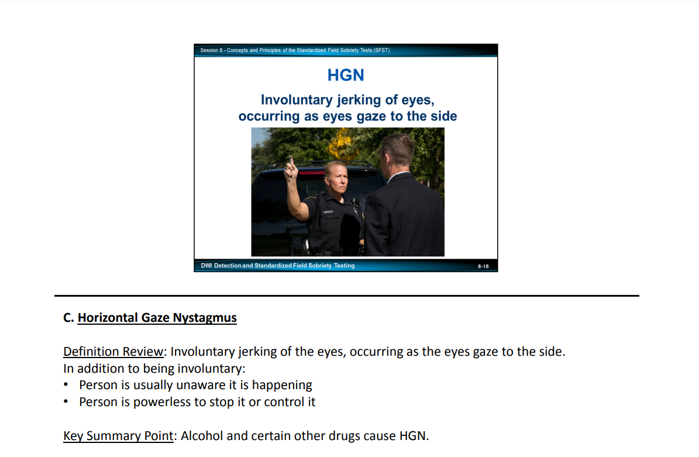

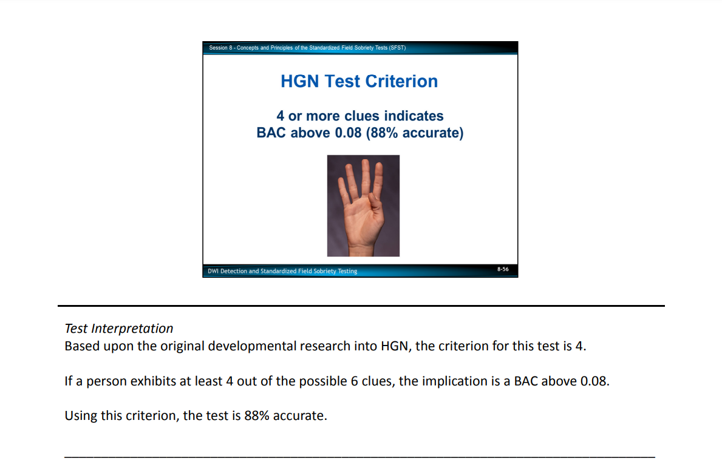
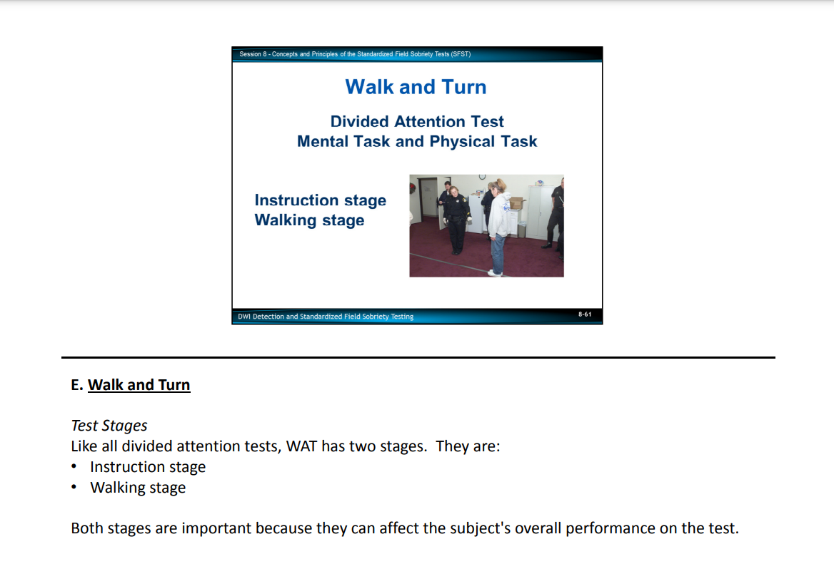

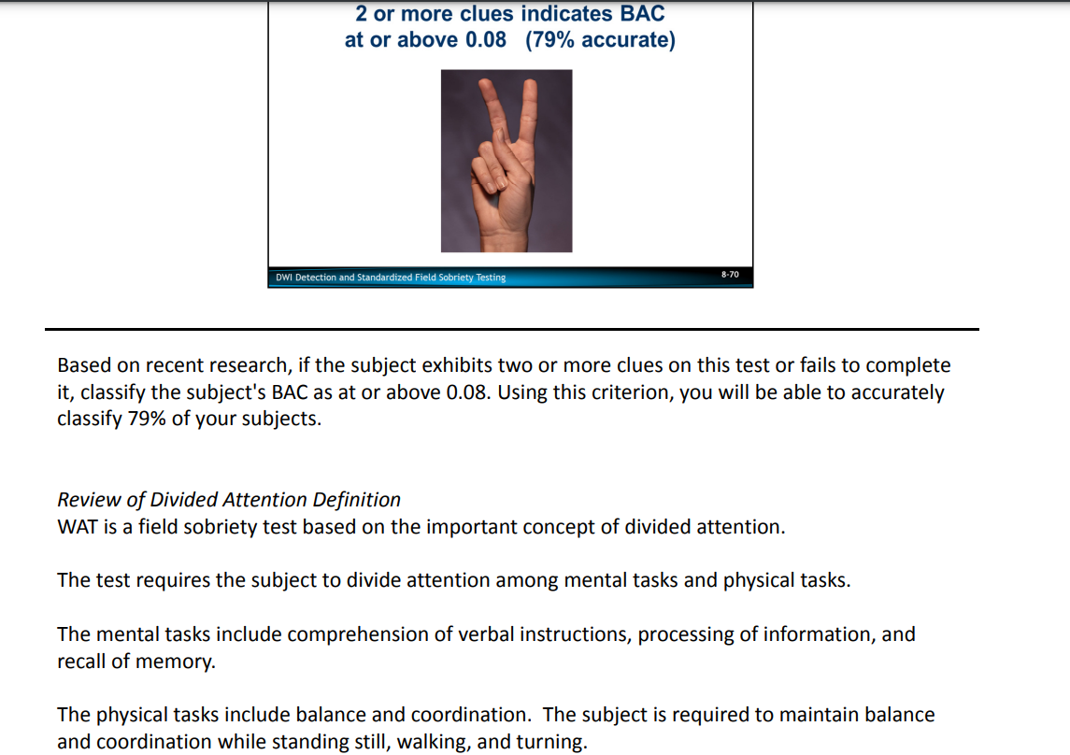

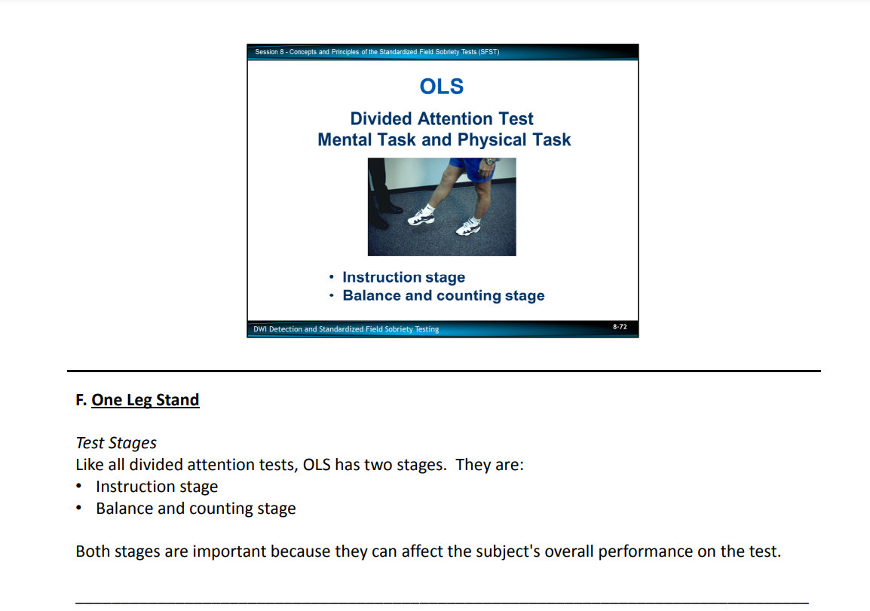

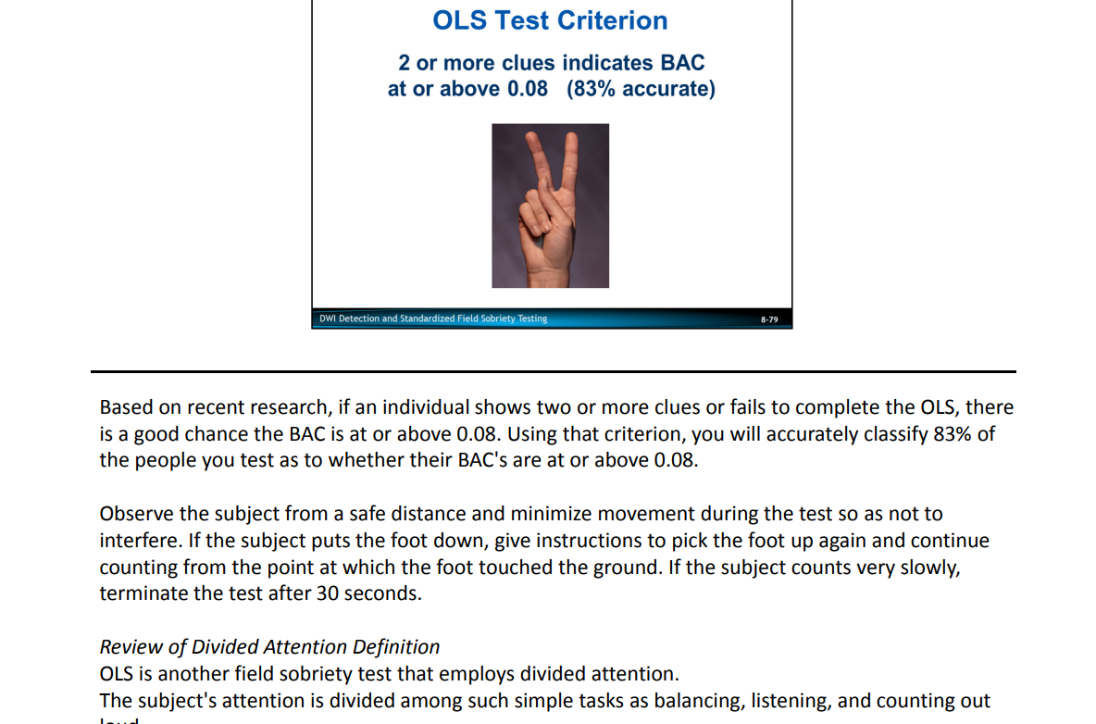

Appendix B
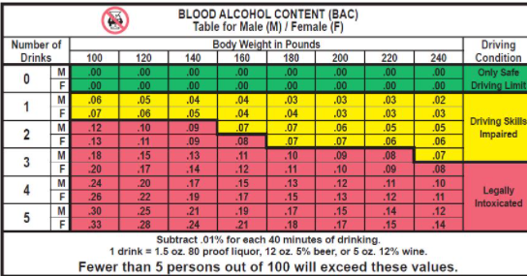

Appendix C

STEPHENSON v. CITY OF FORT SMITH
Email | Print | Comments (0)
No. CA CR 00-155.

- View Case
- Cited Cases
- Citing Case
36 S.W.3d 754 (2000)
71 Ark.App 190
Austin STEPHENSON v. CITY OF FORT SMITH.
Court of Appeals of Arkansas, Divisions II and III.
October 18, 2000.

Attorney(s) appearing for the Case
Claire Borengasser, Deputy Public Defender, Fort Smith, AR, for appellant.
Mark Pryor, Attorney General, by C. Joseph Cordi, Jr., Assistant Attorney General, Little Rock, for appellee.

TERRY CRABTREE, Judge.
The Sebastian County Circuit Court found the appellant, Austin Stephenson, guilty of a second offense driving while intoxicated and sentenced him to forty-five days in the Sebastian County Detention
Center with thirty-one days suspended, fined him $950, and ordered him to complete an alcohol treatment program. In addition, the court found the appellant guilty of refusal to submit to a breath test and suspended the appellant's driver's license for six months. On appeal, the appellant presents
[36 S.W.3d 755]
two arguments: (1) the trial court erred in finding appellant in actual physical control of a motor vehicle within the meaning of the DWI statute, and (2) the trial court erred in finding appellant guilty of refusal to submit to a breath test when the facts did not show appellant in actual physical control of a motor vehicle. We agree and reverse on both points.
The parties stipulated that on July 7, 1999, at approximately 10:22 p.m., Officer Ron Depriest of the Fort Smith Police Department was dispatched to the "Kwik Trip" to investigate a person who was passed out behind the wheel of a vehicle. When he arrived, Officer Depriest saw a white Chevrolet pickup truck parked in front of the Kwik Trip's doors. The officer found the appellant asleep, intoxicated, and sitting behind the steering wheel. Officer Depriest did not see appellant "driving the truck or otherwise physically operating it." However, the driver's side window was down; the motor and the car lights were off; and the keys to the vehicle were on the car dashboard.
For appellant's first point on appeal, he argues that the trial court erred in finding that he was in actual physical control of a motor vehicle. Appellant challenges the sufficiency of the evidence regarding his driving-while-intoxicated conviction. "Actual physical control" of a vehicle is an element of driving while intoxicated under Ark.Code Ann. § 5-65-103 (Repl 1997). Appellant contends that there is insufficient evidence that he had actual physical control of the vehicle.
When the sufficiency of the evidence is challenged on appeal, the test is whether the evidence is substantial. Diehl v. State, 63 Ark.App. 190, 975 S.W.2d 878 (1998). Evidence is substantial if it is forceful enough to compel a conclusion one way or another and goes beyond mere speculation or conjecture. Id. Our court reviews the evidence in the light most favorable to the State and considers only evidence that supports the verdict. Id.
In Dowell v. State, 283 Ark. 161, 671 S.W.2d 740 (1984), our supreme court held that Dowell was not in actual control of his vehicle within the meaning of the DWI statute. Dowell was found asleep in his automobile, which was parked with the motor not running. The keys were in the seat of the vehicle by Dowell's side. Here, the appellant was also found asleep in his vehicle, which was parked with the motor not running. The keys were on the dash of the vehicle. We find that the case at bar is substantially similar to Dowell, with the only difference being the location of the keys in the vehicle. Under these circumstances, we do not wish to create a legal distinction between keys found on the seat of a vehicle and keys found on
the dash of a vehicle. Therefore, we hold that the appellant was not in actual control of his vehicle. Accordingly, we reverse the appellant's conviction for a second offense of driving while intoxicated.
For appellant's second point on appeal, he argues that the trial court erred in finding him guilty of refusal to submit to a breath test when the facts did not show appellant in actual physical control of a motor vehicle. In order to fall under the implied-consent laws, one must operate a motor vehicle or be in actual physical control of a motor vehicle. Ark.Code Ann. § 5-65-202(a) (Repl.1997). Ark.Code Ann. § 5-65-202(a) provides:
Implied consent.
(a) Any person who operates a motor vehicle or is in actual physical control of a motor vehicle in this state shall be deemed to have given consent, subject to the provisions of § 5-65-203, to a chemical test or tests of his or her blood, breath, or urine for the purpose of determining the alcohol or controlled substance content of his or her blood if:
(1) The driver is arrested for any offense arising out of acts alleged to have been committed while the person was driving while intoxicated or driving while there was one-tenth of one percent
[36 S.W.3d 756]
(0.10%) or more alcohol in the person's blood; or
(2) The person is involved in an accident while operating or in actual physical control of a motor vehicle; or
(3) At the time the person is arrested for driving while intoxicated, the law enforcement officer has reasonable cause to believe that the person, while operating or in actual physical control of a motor vehicle, is intoxicated or has one-tenth of one percent (0.10%) or more of alcohol in his or her blood.
(Emphasis added.)
The State suggests that Ark.Code Ann. § 5-65-202(a)(3) requires a person to submit to a chemical test if a law enforcement officer has reasonable cause to believe that a person was operating or was in actual physical control of a motor vehicle. We disagree with the State's interpretation of the statute. We have carefully examined section 202 and find that the excerpt "reasonable cause to believe that the person" modifies and concerns the excerpt "is intoxicated or has one-tenth of one percent (0.10%) or more of alcohol in his or her blood." See State v. Schaub, 310 Ark. 76, 832 S.W.2d 843 (1992). Moreover, we find that the
excerpt "while operating or in actual physical control of a motor vehicle" sets forth a condition precedent to a violation of the implied-consent law as set forth in section 202(a)(3). See id.
Because we find that the appellant was not operating a motor vehicle or in actual physical control of a motor vehicle, we also must reverse the appellant's conviction for refusal to submit to a breath test.
Reversed and dismissed.
ROBBINS, C.J., STROUD and NEAL, JJ., agree.
PITTMAN and MEADS, JJ., dissent.
MARGARET MEADS, Judge, dissenting.
I do not agree with the majority's conclusion that appellant was not in actual physical control of his vehicle, pursuant to Ark.Code Ann. § 5-65-103 (Repl.1997). Under these facts, I believe appellant should be found to have been in actual physical control of his vehicle, and I would affirm both convictions.
The majority relies on Dowell v. State, 283 Ark. 161, 671 S.W.2d 740 (1984), to support its position. However, the majority fails to recognize a significant fact which I believe distinguishes that case from this one. It is true that Dowell was found asleep in his automobile, parked with the motor not running, with the keys in the seat of the vehicle by the appellant's side. Yet it is not clear from the opinion whether Dowell was behind the steering wheel or even whether he was seated in the front seat or back seat of his automobile. The majority assumes, without a factual basis, that the keys were found on the front seat of Dowell's vehicle.
In this case, there is no question that the appellant was sitting behind the steering wheel of his pickup truck and that the keys were on the dash. Thus, I believe the facts are more akin to Wiyott v. State, 284 Ark. 399, 683 S.W.2d 220 (1985), where our supreme court ruled that appellant was in control of a vehicle within the meaning of Ark. Stat. Ann. § 75-2503(a) (Supp.1983), the predecessor to Ark.Code Ann. § 5-65-103. In Wiyott, the appellant was found behind the steering wheel of a vehicle, with the key in the ignition; he attempted to start the vehicle when he awoke; and there was no evidence anyone else had control over the vehicle. The court noted: "[T]he evidence would support the finding that appellant was exercising direct influence over his vehicle and had the authority to manage it. At any moment, he could have awakened and started his vehicle." Id . at 402, 683 S.W.2d 220.
Moreover, I believe that the reasoning of our court in Hodge v. State, 27 Ark.App. 93,

[36 S.W.3d 757]
766 S.W.2d 619 (1989), is persuasive. There we said that "[t]the object of this legislation is to prevent intoxicated persons from not only driving on the highways, but also from having such control over a motor vehicle that they may become a menace to the public at any moment by driving it." 27 Ark.App. at 96, 766 S.W.2d at 620.
Here, although the keys were on the dash of the vehicle and not in the ignition, I think there is substantial circumstantial evidence to establish that appellant had actual physical control of the vehicle, because he was sitting behind the steering wheel, no one else was in the truck, and he could easily have become a menace to the public at any moment by driving.
Thus, I agree with the trial judge's finding that the appellant, at any moment, could have awakened and started the vehicle and thus was in as much control of the vehicle as an intoxicated person could be. I believe there is substantial evidence to support the conclusion that the appellant was in actual physical control of a motor vehicle while intoxicated.
As the majority correctly points out, to fall under the implied-consent laws, one must operate a motor vehicle or be in actual physical control of a motor vehicle. Ark.. Code Ann. § 5-65-202(a) (Supp.1999). Because I believe that the appellant was in actual physical control of a motor vehicle, I would also conclude that he is deemed to have given consent to a breath test, and since the appellant refused the test, he is guilty of refusing to submit to a breath test.
For these reasons, I dissent.
PITTMAN, J., agrees.

Appendix D
671 S.W.2d 740 (1984)
283 Ark. 161
Tommy DOWELL, Appellant, v. STATE of Arkansas, Appellee.
Supreme Court of Arkansas.
July 9, 1984.

Attorney(s) appearing for the Case
Harkey, Walmsley, Belew & Blankenship by John M. Belew, Batesville, for appellant.
Steve Clark, Atty. Gen. by Jack Gillean, Asst. Atty. Gen., Little Rock, for appellee.

PURTLE, Justice.
This is an appeal from the Circuit Court of Independence County, where appellant was convicted of driving while under the influence of intoxicating liquor. The issue on appeal is whether the appellant was in "actual control" of his vehicle within the meaning of the DWI Statute. We hold that he was not.
On October 31, 1982, the appellant was found asleep in his automobile, which was parked with the motor not running, in the driveway of a business near the highway. His keys were in the seat of the vehicle by the appellant's side. At the time of the alleged offense Ark.Stat.Ann. § 75-1027 was in effect and reads as follows: "It is unlawful and punishable as provided in Section 3 [§ 75-1029] of this Act for any person who is under the influence of intoxicating liquor to drive or be in actual control of any vehicle within this State."
Under the circumstances of this case, we hold that the appellant was not in actual control of his vehicle within the
[671 S.W.2d 741]
meaning of the statute. He may not have been the person who drove the vehicle to where it was parked. If he drove it to the place where it was found, he may have become intoxicated later. Criminal laws are to be strictly construed in favor of the accused. Lewis v. State, 220 Ark. 259, 247 S.W.2d 195 (1952). We are without the authority to declare an act to come within the criminal laws of this state by implication. Lewis v. State, supra.
Reversed and dismissed.
ADKISSON, C.J., and HICKMAN, J., concur.
DUDLEY, J., not participating.

